1. Plan on reading passages, if not everything, TWICE.
The first time, read for overall meaning and impressions. The second time, read more carefully. Mark ideas, new vocabulary, etc. Keep in mind, at this stage you have not yet actually started annotating.

2. Before you can analyze, you must COMPREHEND. THIS DOES NOT COUNT AS ANALYSIS but may help your understanding. YOU WILL NOT RECEIVE CREDIT FOR THESE TYPES OF COMMENTS ON YOUR ANNOTATIONS.
a. Summarize important ideas in your own words.
b. Add examples from real life, other books, TV, movies, and so forth.
c. Define words that are new to you.
d. Mark passages that you find confusing with a ???
e. Comment on things that intrigue, impress, surprise, disturb, etc.
f. Feel free to draw picture when a visual connection is appropriate

3. Begin annotating by marking specific elements or features of the text and then explaining WHY and HOW those things are significant.

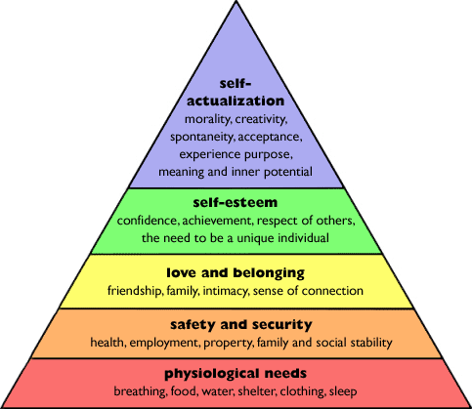
a. Word choice: How does the writer’s choice in words support or contrast the plot within the text? Are the word choices very formal and sophisticated or are they simple? Could these words have multiple meanings or connotations?

b. Figurative language: Why are the examples of figurative language included in the first place? Is there a pattern (do all the similes deal with nature)? Do not simply write “simile.” Explain what it means and why it’s important.

c. Historical/social context: What do certain actions/statements indicate about society (both modern and the period when the text was written)? What does the text say about human nature?

d. Weirdness: If something strikes you as strange, it probably is. Try to figure out why that strange thing occurred, and what it means.

e. Obvious: You are familiar with many common elements of analysis thanks to T.V. and movies. What does a cloudy sky indicate? The color red, or pink, or black? Position (why do castles typically appear on a hill; why do people kneel)?

N.B. DO NOT WRITE NON-SENSE. AVOID “IMAGERY,” “THE READER,” AND “FEELINGS” AT ALL COSTS. If you write that imagery “helps the reader imagine” or “paints a clear picture,” “makes the author’s meaning clear,” or “creates a feeling of anger/sadness/pity for the reader,” that means nothing. Feelings ≠ Analysis. Do not do that. You have been warned.

Maslow’s Hierarchy of Needs
Steps to Annotation:
- Summarize what’s happening in the passage.
- Identify:
  - What stands out to you?
  - What figurative language (e.g. repetition, similes, metaphors, symbols) do you see?
    - Which specific words stand out to you the most?
What do you think these things mean/represent/imply?
What are the implications/associations with these words (connotation? Does the word generally deal with/describe mental, physical, emotional, or social things?)?
- Connect your ideas
Do you see any patterns/trends?
What is the passage saying as a whole?

