Clueless Man Claims Territory in North Sudan to Make Daughter Princess
- July 13th, 2014

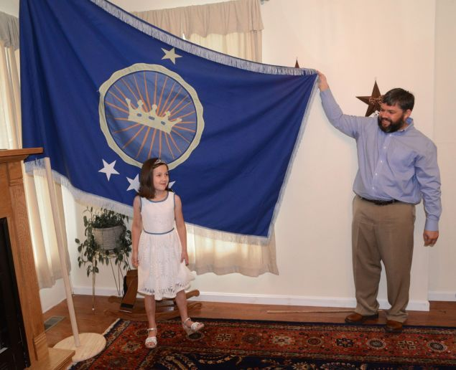
A story ran in the Washington Post yesterday that is equal parts cringeworthy and baffling. A Virginia man, out of the desire to prove to his children that he'd "go to the ends of the earth to make their wishes and dreams come true," claimed land along the Sudanese border to fulfill his daughter's wish to become a princess.
The story starts like this:
Jeremiah Heaton was playing with his daughter in their Abingdon, Va., home last winter when she asked whether she could be a real princess.
Most parents would then say, "No, you cant. It's just now how things work." Not Heaton. He—for some reason—said yes, okay. Sure, we'll figure it out.
"As a parent you sometimes go down paths you never thought you would," Heaton said.
Like the endless aisles of a Toys "R" Us when you said you wouldn't step into that store ever again. But when Heaton says "paths you never thought you would," he means something entirely different.
Within months, Heaton was journeying through the desolate southern stretches of Egypt and into an unclaimed 800-square-mile patch of arid desert. There, on June 16 — Emily's seventh birthday — he planted a blue flag with four stars and a crown on a rocky hill. The area, a sandy expanse sitting along the Sudanese border, morphed from what locals call Bir Tawil into what Heaton and his family call the "Kingdom of North Sudan."
Nothing to see here—just a man getting some land to give to his daughter. In Africa.
In order for Heaton's "kingdom" to be internationally recognized, he will need a few more things besides a handmade flag (which his children designed): "legal recognition from neighboring countries, the United Nations or other groups to have actual political control of the land," Sheila Carapico, a professor of political science and international studies told the Bristol Herald Courier last week.
Heaton, however, is confident that all will go well with his declaration of sovereignty in an African nation which is not his home and has never been his home.
Heaton, who ran for Congress out of Virginia's 9th district in 2012 and lost, plans to reach out to the African Union for assistance in formally establishing the Kingdom of North Sudan and said that he is confident they will welcome him. Representatives from the Egyptian and Sudanese embassies in Washington did not respond to requests for comment Saturday.
According to Heaton's assessment of the pesky politics in founding his new kingdom, he believes love will conquer all.
"I founded the nation in love for my daughter," Heaton said.
Heaton's journey hasn't been without its complications, though. His initial worry was that he was entering into "a toxic environment." Hm.
Heaton's daughter Emily has requested the kingdom be turned into agricultural production center, which Heaton is certain is the first step in solidifying a positive relationship between the sovereignly declared Kingdom of North Sudan and the Sudanese and Egyptian people.

