Comic Symbolism
Object | Description (include pg. number) | Analysis | Visual Depiction
Sharp thigh sword

Bag of winds

Circe’s shining doors

Circe’s long wand

Fast Black Ship

Potion of malignant drugs

Batman’s Boomerang |  |  | 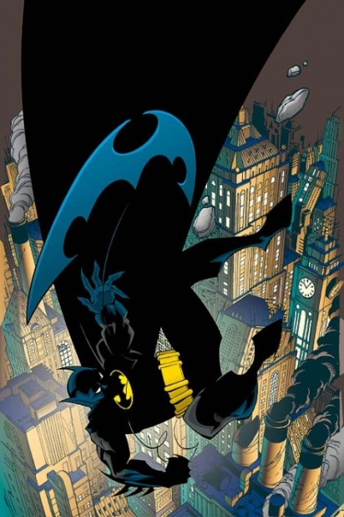
Capt. America’s Shield |  |  | 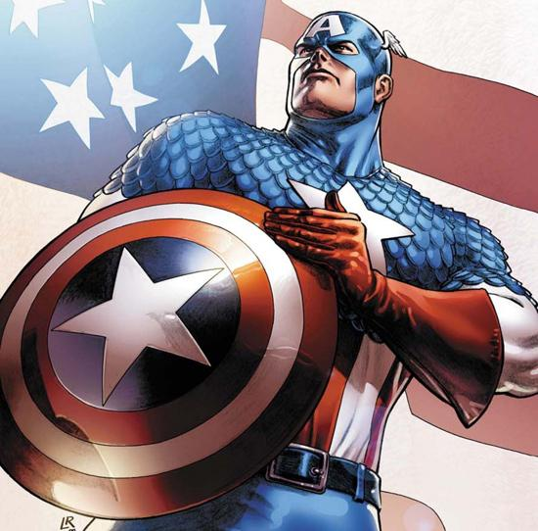
Thor’s Hammer |  |  | 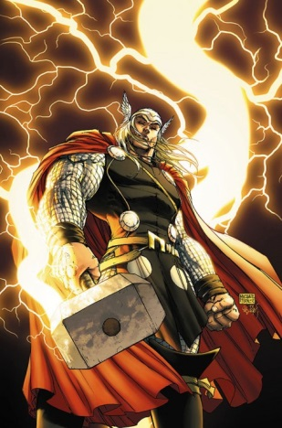
Wonder Woman’s Lasso of Truth |  |  | 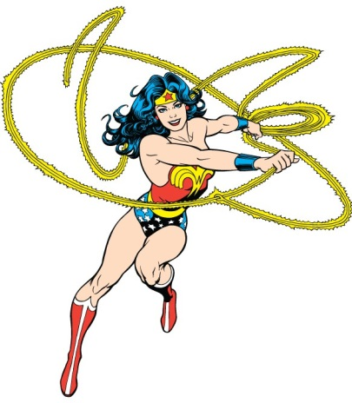
Clark Kent’s glasses

