Good News, You Guys Everyone! English Is Becoming More Inclusive
MEGAN GARBERNOV 5 2012, 6:03 PM ET
4
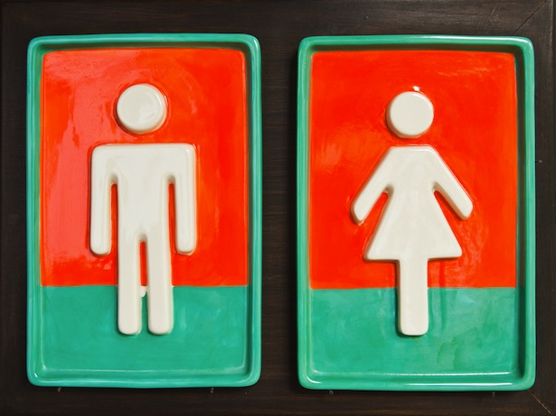
A win for humanity is a loss for mankind.
In 1789, William Marshall observed a linguistic anomaly that had arisen in the vale of Gloucester:
Beside these and various other misapplications (as they for them - I for me, &c.), an extra pronoun is here in use - ou : a pronoun of the singular number; - analogous with the plural they ; - being applied either in a masculine, a feminine, or a neuter sense. Thus "ou will" expresses either he will, she will, or it will.
Gloucester's innovation, alas, did not spread very far--and certainly not to the States. Which is evidenced not just by the fact that Neil Armstrong took his giant leap not for humanity, but for "mankind," but also by the more recent fact that a Google search for "he she vs they" returns more than 300 million results. When it comes to our language's pronouns, we are confused. We are awkward. And we are, worst of all, stuck with what we have. We know that many words and conventions in our language inherently exclude half the population. But we know as well that this linguistic sexism is so common as to seem benign. Neil Armstrong, after all, wasn't snubbing the ladies; he was fitting his time.
Still. For a number of reasons--from the psychological to the symbolic--the default masculine is problematic. Even (and especially) when it comes to such small, ubiquitous words as "he" and "him." "Since at least the early 1970s," writes the gender theorist Brian Earp in a new paper published in Journal for Communication and Culture, "feminist linguists such as Wendy Martyna, Carolyn Korsmeyer, Janice Moulton, and others ... have made compelling arguments against the use of he/man language, advocating its abolition wherever it may be found."
Which led him to wonder: "Has anyone been listening? Have there been any changes in sexist language use over the past thirty (or so) years?"
Yes, he answers. And: yes. Overall, Earp concludes, our use of masculine pronouns--what Martyna calls an "implicit equation of maleness with humanness"--is declining. "He" as our default pronoun is giving way to the more inclusive "he or she," or the even more inclusive "their." And "mankind" is giving way, demonstrably, to "humankind."
It's The End of Men ... English pronoun edition.
Earp's findings, published in a paper in the Journal for Communication and Culture, are based on three separate-but-related studies. In the first, Earp used the rich archives of JSTOR, the repository of academic papers, to analyze the use of the term "mankind"--as well as the gendered pronouns "he," "she," and the like--in work published between 1970 and 2000. In the second, Earp applied that search-term approach to the same thirty-year period in that rich archive of more popular writing: the New York Times. In the third, Earp created his own experiment asking a sample of participants to complete a sentence: "The moral individual is ..." He then scanned the open-field replies for the pronouns they contained.
Earp's results varied in their particulars across the three studies. But the trend he identified was universal. "Across three domains--academic, popular, and personal--the results are clear," Earp writes. "He/man language is increasingly less used, and nonsexist alternatives are on the rise." Among the academic literature, Earp recorded a marked decline in the use of the term "mankind": from 3,149 instances in the span between 1970 and 1971 to 1,929 instances in the 1999-2000 span--a 38.8 percent decrease. "Humankind," on the other hand, saw a 1,890-percent increase: from 63 articles in 1970-1971 to 1,192 articles in 1999-2000. "He or she," for its part, saw a 1,194-percent increase.
For the Times, for the same span, Earp recorded a 65.5-percent decrease for "mankind" (461 articles in 1970-1971 to 159 in 1999-2000) and a 1,266-percent increase for "humankind" (6 articles in 1970-1971 to 76 in 1999-2000). "He or she," similarly, rose from 43 articles to 346--an increase of 804 percent.
Earp's participant-based study, interestingly, revealed the most ambiguity. Nearly half of its 64 participants--27, or 42 percent--either used an inconsistent mix of pronouns, used only one pronoun (such that he couldn't measure consistency), or avoided the use of pronouns altogether. Of the 37 remaining respondents:
- 10 used the generic masculine
- 7 used the singular "they"
- 13 used "he or she"-type treatments
- 5 used the generic feminine
- 2 used the indefinite "one"
And of those who used a consistent singular approach to the generic pronoun:
- 27 percent used the generic masculine
- 19 percent used the singular "they"
- 35 percent used "he or she"-type treatments
- 13.5 percent used the generic feminine
- 5.5 percent used the indefinite "one"
The bottom line: overall progress toward pronoun equality. But, on a user-by-user level, confusion, as well. And much of the awkwardness can be traced directly to the fact that English, as it's used in 2012, lacks its own version of Marshall's "ou." Or of Sweden's "hen." Or of Persian's "u." We have "one" and "they" and "it" and "their," but those words, to readers, often appear to be exactly what they are: hacks. Workarounds. Fallbacks. Often, given the linguistic resources available to us, we're made to make the choice that language, at its best, shouldn't demand of its users: aesthetics on the one hand, propriety on the other. "Him" sounds better, but "him or her" is fairer. What's a girl/guy/person to do? Barring the radical introduction of a brand-new pronoun, how does an English speaker react if she does not want to compromise? How should one handle the awkward, suboptimal choices available to him? How do we deal with a language that is becoming more awkward as it's becoming more impartial? "It's enough," George Bernard Shaw might say, "to drive anyone out of their senses."

