Famous Novelists on Symbolism in Their Work and Whether It Was Intentional
Lucas Reilly

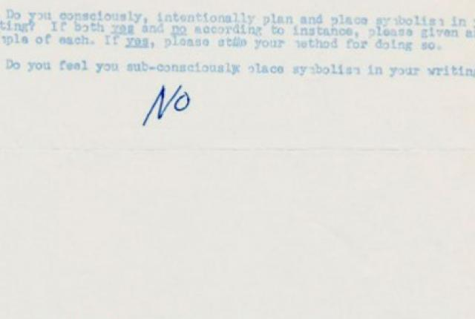
It was 1963, and 16-year-old Bruce McAllister was sick of symbol-hunting in English class. Rather than quarrel with his teacher, he went straight to the source: McAllister mailed a crude, four-question survey to 150 novelists, asking if they intentionally planted symbolism in their work. Seventy-five authors responded. Here’s what 12 of them had to say. (Copies of the survey responses can be found at the Paris Review.)

MCALLISTER'S LETTER
“My definition of symbolism as used in this questionnaire is represented by this example: InThe Scarlet Letter there are four major characters. Some say that Hawthorne meant those four to be Nature, Religion, Science or other similar symbols in disguise. They apply the actions of the four in the story to what is presently happening or will happen to Nature, Religion, Science, etc.”
Ayn Rand: “This is not a ‘definition,’ it is not true—and therefore, your questions do not make sense.”
MacKinlay Kantor: “Nonsense, young man, write your own research paper. Don’t expect others to do the work for you.”

QUESTION 1
“Do you consciously, intentionally plan and place symbolism in your writing?... If yes, please state your method for doing so. Do you feel you sub-consciously place symbolism in your writing?”
Jack Kerouac: "No."
Isaac Asimov: “Consciously? Heavens, no! Unconsciously? How can one avoid it?”
Joseph Heller: “Yes, I do intentionally rely on symbolism in my writing, but not to the extent that many people have stated…No, I do not subconsciously place symbolism in my writing, although there are inevitably many occasions when events acquire a meaning additional to the one originally intended.”
Ray Bradbury: “No, I never consciously place symbolism in my writing. That would be a self-conscious exercise and self-consciousness is defeating to any creative act. Better to let the subconscious do the work for you, and get out of the way. The best symbolism is always unsuspected and natural."
John Updike: “Yes—I have no method; there is no method in writing fiction; you don’t seem to understand.”
Norman Mailer: “I’m not sure it’s a good idea for a working novelist to concern himself too much with the technical aspects of the matter. Generally, the best symbols in a novel are those you become aware of only after you finish the work.”
Ralph Ellison: “Symbolism arises out of action…Once a writer is conscious of the implicit symbolism which arises in the course of a narrative, he may take advantage of them and manipulate them consciously as a further resource of his art. Symbols which are imposed upon fiction from the outside tend to leave the reader dissatisfied by making him aware that something extraneous is added.”
Saul Bellow: “A ‘symbol’ grows in its own way, out of the facts.”
Richard Hughes: “[Consciously?] No. [Subconsciously?] Probably yes. After all, to a lesser extent, the same is true of our daily conversation—in fact, of everything we think and say and do.”

QUESTION 2
“Do readers ever infer that there is symbolism in your writing where you had not intended it to be? If so, what is your feeling about this type of inference? (Humorous? annoying? etc.?)”
Ray Bradbury:
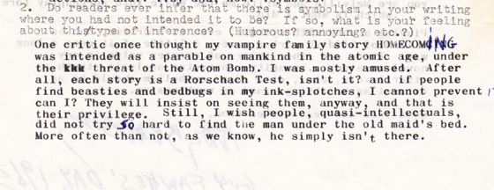
Ralph Ellison: “Yes, readers often infer that there is symbolism in my work, which I do not intend. My reaction is sometimes annoyance. It is sometimes humorous. It is sometimes even pleasant, indicating that the reader’s mind has collaborated in a creative way with what I have written.”
Saul Bellow: “They most certainly do. Symbol-hunting is absurd.”
Joseph Heller: “This happens often, and in every case there is good reason for the inference; in many cases, I have been able to learn something about my own book, for readers have seen much in the book that is there, although I was not aware of it being there.”
John Updike: “Once in a while—usually they do not (see the) symbols that are there.”
Jack Kerouac: “Both, depending how busy I am.”

QUESTIONS 3
“Do you feel that the great writers of classics consciously, intentionally planned and placed symbols in their writing? ... Do you feel that they placed it there sub-consciously?”
John Updike:
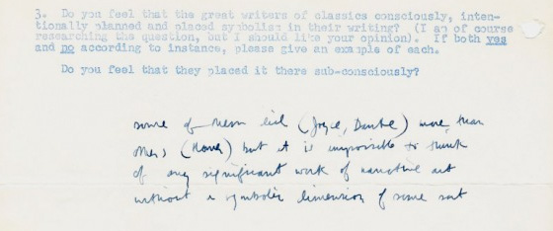
[“Some of them did (Joyce, Dante) more than others (Homer) but it is impossible to think of any significant work of narrative art without a symbolic dimension of some sort.”]
Ray Bradbury: “This is a question you must research yourself.”
Joseph Heller: “The more sophisticated the writer, I would guess, the smaller the use of symbols in the strictest sense and the greater the attempt to achieve the effects of symbolism in more subtle ways. “
Ralph Ellison: “Man is a symbol-making and –using animal. Language itself is a symbolic form of communication. The great writers all used symbols as a means of controlling the form of their fiction. Some place it there subconsciously, discovered it and then developed it. Others started out consciously aware and in some instances shaped the fiction to the symbols.”
Jack Kerouac: “Come off of it—there are all kinds of ‘classics’—Sterne used no symbolism, Joyce did.”

QUESTION 4
"Do you have anything to remark concerning the subject under study, or anything you believe to be pertinent to such a study?"
Richard Hughes:
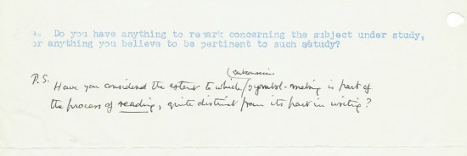
[“Have you considered the extent to which subconscious symbol-making is part of the process of reading, quite distinct from its part in writing?”]
Jack Kerouac: “Symbolism is alright in ‘fiction’ but I tell true life stories simply about what happened to people I knew.”
John Updike: “It would be better for you to do your own thinking on this sort of thing.”
Iris Murdoch: “There is much more symbolism in ordinary life than some critics seem to realize.”
Ray Bradbury: “Not much to say except to warn you not to get too serious about all this, if you want to become a writer of fiction in the future. If you intend to become a critic, that is a Whale of another color…Playing around with symbols, even as a critic, can be a kind of kiddish parlor game. A little of it goes a long way. There are other things of greater value in any novel or story…humanity, character analysis, truth on other levels…Good symbolism should be as natural as breathing…and as unobtrusive.”
* * *
In case you were wondering, McAllister eventually became an English professor.

