Four-Eyes For The Win: DRAFT

Forget hindsight, foresight, insight, and everything in between—sight, be it near or far, is ill-defined, and nothing in life is 20/20. Perhaps that is why superheroes from Clark Kent to Peter Parker and Scott Summers wear glasses, at least until they suit up in capes and spandex. The newest initiate into this illustrious group of nearsighted nerds is the wizard boy-wonder Harry Potter. J.K. Rowling’s seven-book series about a magical orphan battling the forces of the evil Lord Voldemort, all while trying to pass the wizarding version of standardized tests, inspired the millions of children who grew up with Harry. Years of Halloween costumes and themed parties, not to mention eight major motion pictures, ensured everyone is well-acquainted with Harry’s scarlet and gold Gryffindor scarf, lightning-bolt scar, and dark-rimmed round glasses. Over the course of the Harry Potter series, Harry’s glasses characterize the various ways he is viewed, as his independence and success are contingent upon embracing his peculiarities to put his past behind him, while looking outside the defined parameters of the world they create.
As the novel character who defined a generation, the ways in which Harry is “characterized” by his glasses are numerous. Stereotypical associations with the optically-impaired are seen in the Oxford English Dictionaries definition “to engrave, imprint; to inscribe, write; to define in form or outline” (“Characterize” 1.1). Not only is “writ[ing]” involved, as expected when discussing a novel, but “engrave, imprint” and “inscribe” all contain prefixes meaning “in” or “into,” revealing the permanent and fixed nature of the word. In the case of glasses, their meaning has already been “impress[ed]” upon children from a young age, who find the outline of their glasses “engraved” into the bridge of their noses from continued wear, allowing their peers to identify them as stereotypical nerds, even if they choose to take them off. Harry’s glasses “define” him, but only in the most superficial sense, “outlin[ing]” him “in form” only, as their importance is purely physical (“Characterize” 1.1), though their impact is unavoidable.
“Characterization” does not always need to be superficial or negative, however, as seen in Dictionary.com’s definition: “to attribute character to” (“Characterize” 3). This definition highlights the mental and moral aspects of “character” involved in “characterizing,” ensuring individuals possess not only glasses, but also honesty, courage, and integrity. Compared to the ingrained societal judgments about the typical glasses wearer, this “character” than actual, though in his case, Harry’s glasses make him more ideal than real. Frequently featured on the faces of superhero alter-egos, the wise old men, and rule-abiding bookworms in any series is sure to sport glasses. In this way, Harry’s glasses are a credit to him, as they “attribute” various positive associations, though no specific proof is necessary (“Characterize” 3).
Another definition of “characterize” from the Oxford English Dictionaries negotiates these two extremes: “to describe or delineate the character or peculiar qualities of (a person or thing)” (“Characterize” 3.3). Harry is still outlined in words or drawing, as his character is “delineate[d],” but now his actual “character” or “qualities” as “a person” are communicated through his glasses. This “characterization” hopes to get at his “peculiar[ities],” as his distinctive, and admittedly odd, characteristics are what make Harry human, and, moreover, what make Harry Harry. “Peculiar” quirks are both alienating and humanizing, as are glasses, as they are simultaneously normal and foreign, particularly on the face that is both boy and wizard, fantasy and reality (“Characterize” 3.3).
In her “writ[ing]” J.K. Rowling uses many common stereotypes that “define” glasses, and stigma that is “impress[ed]” upon those who wear them (“Characterize” 1.1). Before discovering he is a wizard, Harry is already cast as an outsider by his glasses. Harry’s “broken glasses” are a physical marker that he is “odd” and result in social isolation, as “Harry had no one” (Sorcerer’s Stone 30). This isolation is a direct result of societal pressure, as Harry’s glasses are “held together with a lot of Scotch tape because of all the times Dudley had punched him” causing him to be “laughed at” by his peers because “nobody like to disagree with Dudley’s gang” (Sorcerer’s Stone 20, 24, 30). At this point, “the only thing Harry like[s] about his own appearance” is his scar “shaped like a bolt of lightning” which makes unique, as opposed to his “broken glasses” which just remind him that he is from a broken home, and doesn’t see life in the same way as the Dursleys. Dudley Dursley’s views on glasses are aligned with society outside the realm of fantasy, as studies found that, besides being associated with nerds and weaklings, “round frames (‘Harry Potter’ glasses) are often less appealing to children concerned about appearances” (Castanon Holguin et. al 927). The Dursleys intentionally utilize this negative view to keep Harry downtrodden in hopes of stomping out his wizardness.
Glasses result in not only emotional, but also physical pain. As a removable accessory, Harry’s glasses cause him difficulties when they are repeatedly lost and returned, though this reunion is often a painful one. When trying to disguise his identity in The Deathly Hallows, Harry is captured and catalogued, but not before his captor muses, “‘I thought you wore glasses, Potter?’” (Deathly Hallows 453). Although Hermione has just altered every other aspect of his physical appearance in an attempt to avoid identification, Harry’s glasses are located and “rammed back onto his face.” The force and violence of this reunion is much like that of a battering ram trying to break down a door, in this case the glasses are the force of society’s mockery and set ideas about his appearance “ramm[ing]” against Harry’s attempt to define his own identity (Deathly Hallows 453). Even when the Death Eaters believe he’s dead, “some slammed Harry’s glasses back onto his face with deliberate force” (Deathly Hallows 727). His glasses provide an excuse for abuse that would have not occurred otherwise, while ensuring he would be identifiable to his supporters, as his trademark glasses are being used to cause their owner physical pain and his supporters emotional pain.
Even when still in Harry’s possession, they “imprint” themselves on his face. Upon returning to his body from King’s Cross Station styled Purgatory, the first thing Harry feels are “the hinge of his glasses, which had been knocked sideways by the fall, cutting into his temples” (Deathly Hallows 724). This welcome-back party is far from friendly, however, as the “sideways” glasses are a reminder that Harry is still in the midst of a battle, “cutting into his temples” to forcibly remind him of his body is vulnerable, even if his mind is not. As long as he is alive, Harry’s identity and physicality will be defined by his glasses.
Harry’s glasses represent a lack of control. When Aunt Petunia sheers Harry’s head, even thinking to leave his bangs “‘to hide that horrible scar,’” Harry worries about going to school where he is “already laughed at” thanks to his “taped glasses,” but wakes up to find that all of his hair has magically grown back (Sorcerer’s Stone 30). However, there is no magic solution for imperfect sight. This is true not just for Harry, but the entire Wizarding World. Magic may mend broken bones, fix frizzy hair, or revive people who’ve been petrified, but it is powerless to cure those who don’t see clearly. Even when wizards transfigure themselves into animals, their animagi form bears the markings of their glasses, as evidenced by Rita Skeeter and Minerva McGonagall, who “wear[s] glasses exactly the shape of the marking the cat had had around its eyes” (9). No matter the form, a wizard must wear his glasses. Rowling was “outraged” when an Italian edition appear featuring Harry sans glasses (Boquet). The redesigned American covers make Harry’s glasses an even greater focal point, often appearing as Harry’s only discernable feature, as seen in the Order of the Phoenix cover art (see fig. 1), where the Harry’s glasses alone catch the light, while the rest of his figure is thrown into darkness. This novel appears at the point in the series when Harry is least accepted by society; his peers view him as needy, desperate, or delusional, and he begins to see through Lord Voldemort’s eyes in his dreams.
The prominence of Harry’s glasses should come as no surprise, however, as the newly designed covers are intended to “‘attract[] the interest of a new generation of 8- and 9- year-olds who may know Harry mostly through the movies’” (Minzesheimer). Daniel Radcliffe, who plays the eponymous role, states that “I just put on my glasses and then I became Harry again” (“Top 10 Best Daniel Radcliffe Quotes”). When asked what he wanted to keep from the set, Radcliffe revealed, “‘I would have stolen it had they not given it to me…I’ve got two sets of the glasses” (Topel). His attachment to the glasses is so strong in part because “one [pair was from] the first movie which are tiny now, and one from the last movie” (Topel). Not only have viewers spent years seeing Harry with glasses, but they have also become a symbol of his journey into adulthood as he becomes disillusioned and begins to view the harsh realities of the world, transitioning from “tiny” glasses, with a similarly tiny worldview, to an adult’s view of the world. It should be noted that Bloomsbury, Rowling’s British publisher, attempted to market an “adult” edition of the books, whose covers feature neither Harry nor his glasses, but symbols of each individual novel (see fig. 2). This fragmented picture of Harry’s quest is presented to adults who are presumably less captivated by the hero who helms the series.
Harry has almost been too well marketed to children, however, “attribut[ing]” to the idealization of the character’s “character” and his glasses (“Characterize” 3). This hero-worship of Harry is a result of movie magic—Radcliffe predominately wears “‘lens-less’” glasses that serve no practical purpose and are purely symbolic of status (Topel). Admittedly, glasses have always been viewed as a stereotype with some benefits. Glasses-wearers appeared “smarter… and more honest…regardless of whether the child picking wore glasses” (Walline et. al), and some children feel “‘smarter’ and ‘faster’ with their glasses” (Koklanis). However, the same study also noted that children still felt their glasses “caused feelings of stigma” (Koklanis).
Rowling hoped Harry would transform both of these banalities. “I had glasses all through my childhood and I was sick and tired of the person in the books who wore the glasses was always the brainy one,” specifically setting out to create “a hero wearing glasses” (“Read the FULL JK Rowling interview”). Both the books and movies are clearly cognizant of the typecasting of bespectacled characters. Through Dumbledore, Rowling utilizes the archetypal wise old man; his long white beard and “blue eyes [that] were light, bright, and sparkling behind half-moon spectacles” introduce the reader to the Wizarding World (Sorcerer’s Stone 8). He also serves the classic mentor, guiding Harry through the past with the Pensieve, as depicted on the cover of Harry Potter and the Half-Blood Prince (fig. 3), both mentor and mentee’s glasses are a prominently featured.
The movies capitalize on these age-old stereotypes for comedic effect. In the Chamber of Secrets, Harry spies on Malfoy by transforming into one of his henchmen, but finds himself needing his glasses as the Polyjuice Potion starts to wear off. When Malfoy questions him, Harry says he’s they’re reading glasses, to which Malfoy replies, “I didn’t know you could read” (Columbus), typecasting the nerd, villain, and buffoon in one fell swoop. Harry’s glasses often appear to be no more than a prop, as they “didn’t get one scratch during the Battle of Hogwarts [in the Deathly Hallows: Part 2], and yet, there was blood around [Harry’s] eyes behind them” (Bierly). On the covers of both the Sorcerer’s Stone and the Order of the Phoenix Harry looks over, rather than through, his glasses, although the books maintain that his “‘eyesight really is awful’” (see fig. 4, fig. 5; Deathly Hallows 52). This use of Harry’s glasses in various visual media without a medical need is undoubtedly reflected in the fact that Radcliffe’s glasses were “lens-less” (Topel), and led to their use as a status symbol. Major retailers began carrying a range of the round frames and reported “an upsurge of children going for eye tests, many of whom were very upset because they did not fail” (Maher), while an editorial in The Washington Post marveled that this is “now perfectly OK to show up to school wearing round taped-fixed glasses” (Stuever).
Rather than the lightning bolt scar actually marks Harry alone as a hero and individual, his glasses, which mark millions of faces across the globe, became symbolic of all Harry stands for. The quintessential courageous Gryffindor, it is no wonder that “spectacle wearer[s] appeared smarter…and more honest” (Walline et. al). Boys even “looked better at playing sports”—fitting, as Harry is an accomplished Quidditch player (Walline et. all). Harry is a seeker, a position symbolic of the heroic quester that ironically requires keen sight above all else. And sight is all Harry requires. During a particularly grueling match, Hermione makes Harry’s glasses impervious to the harsh storm raging outside. “Harry was still numb with cold, still wetter than he’d ever been in his life, but he could see,” and that was all he needed to win the match for his team (Prisoner of Azkaban 177). Through Harry Potter, the typically effeminate glasses have become attached to a sports start, becoming a symbol of masculinity.
Harry’s metaphoric sight allows him to see through various plots, from the plot to steal to the Sorcerer’s Stone to Voldemort’s return. It is his sight that empowers him to stand up to friends, teachers, and the Ministry of Magic alike, as Harry is confident that he sees the truth. Even when fighting the Basilisk, a monster who kills with its gaze, Harry “couldn’t help it—he opened his eyes” (Chamber of Secrets 318). Harry is both hero, refusing to be blind to evil and injustice, and Everyman, as he “[can’t] help” his natural human curiosity, even at the potential cost of his own life. In contrast, Voldemort has snakelike red slits for eyes as he is treacherous, inhuman, and refuses to see any view but his own. Harry’s exemplary moral character and quest for truth is also seen in Legendary Auror Mad-Eye Moody, who lives out his motto “‘Constant vigilance’” with a magical eye that can view 360 degrees and see through walls (Goblet of Fire).
Like Harry, however, Moody’s “peculiar” glasses, which “delineate” him from others ultimately cause him to struggle to maintain control over his “character” and identity (“Characterize” 3.3). The Moody that Harry becomes acquainted with in the Goblet of Fire turns out to be an imposter who stole original Moody’s magical eye and other “peculiar qualities” to convincingly pass as real thing. Moody’s friends accept the imposter as he possesses the magical eye and drinks out of a hip flask, demonstrating the downside of having a symbolic item. When an object characterizes you, possession of the object creates person, and identity is no longer permanently physically tied to the character it belongs to. When your identity can be removed, it can be stolen and used against you. After Moody’s death, Dolores Umbridge steals his eye and uses it to spy on those who might undermine her attempts to enforce purity in wizard bloodlines—a mission that Moody would have never supported.
The same question arises as to whether Harry wears the glasses or the glasses wear Harry. Rowling revealed that the glasses have a “symbolic function” as “Harry is the eyes on to the books” which are “always from Harry’s point of view” (“Read the FULL JK Rowling interview”), but the books are written from the third, rather than first person, point of view. The reader uses, rather than becomes a part of, Harry, just as his glasses do. The limitations of sight and loss of control implied by glasses are repeatedly remarked upon, as Dumbledore remarks that it is “strange how nearsighted” Harry has become when focused on seeing his family again in the Mirror of Erised and when Harry wakes up in the hospital after his first real battle with Voldemort, he tries to catch the snitch, only to realize “It was a pair of glasses. How strange” (Sorcerer’s Stone 213, 295). Readers often fails to notice the parallels between Harry’s limited sight and their own, as they see only through Harry, though they believe they see clearly and without limitation, just as Harry sees only through his glasses.
While Harry spots various plots throughout the series, he never sees a single one clearly and correctly. Harry depends on his glasses, having to “holding his broken glasses up to his eyes” (citation needed) forgetting his imperfect vision. This lack of awareness allows Harry to be an idealist, and unintentional egoist, accidently releasing a boa constrictor by eliminating the glass that constrains it, and flying off to the Department of Mysteries to rescue Sirius based on a what he saw in a vision. Both events ended in disaster, as the invisible barrier, in the form of glass or metaphor, between Harry and the truth there is protect him and others. The boa constrictor causes panic before being recaptured, Harry is punished, and Sirius dies due to Harry’s confidence in his impaired sight.
When Harry looks at his own reflection, he sees his parents, not himself. Upon discovering the Mirror of Erised, Harry, an orphan, sees his entire family surrounding him, recognizable because the woman had “eyes just like mine,” and the man “wore glasses” (Sorcerer’s Stone 208). This sense of physical connection to his parents gives Harry “comfort and strength” (Zimmerman 207), and reinforce his sense of self-righteousness, allowing him to accomplish great deeds in the memory of his muggle born mother, whose eyes he has, and pureblood father, whose glasses he wears, both of whom fought against Voldemort’s desire for a master race of wizards. However, his “eyes behind his glasses were bright green,” as he is constantly reminded of the characteristics he that still belong to his parents, and each book begins with a physical description reminding the reader of his parents’ past that he can never get out from “behind” (Prisoner of Azkaban 6). Harry’s sense of self-sacrifice is a result of his loss of sense of self, as illustrated when he looks into the Mirror of Ersied, peering up at the parents as they were, rather than forward at himself as he is (see fig. 6).
This “clue to his vulnerability” which defines his “Everyman nature” makes Harry relatable and likeable, though it keeps him from growing independently (“Read the FULL JK Rowling interview”; Nikolajeva 233). Throughout the series, Harry remains dependent on his parents for strength: he believes he sees his father saves him from Dementors in the Prisoner of Azkaban, and his parents’ ghosts direct him though his battle with in the Goblet of Fire, which is notably the only book cover where Harry’s glasses bear tape, he wears a smile, and is surrounded by his peers (fig. 7). It is only after beginning to shed this child-like reliance on his parents’ instruction that Harry grows in the most literal sense, having the “slightly unhealthy look of someone who has grown a lot in a short space of time” () in Order of the Phoenix, and having “‘grown about a foot over the summer’” () by the Half-blood Prince. Between these two years Harry has been alienated by his peers and taken lessons from Professor Snape in Occlumency, the study of closing one’s mind from outside forces, both of which have allowed him to begin forming an independent sense of self.
One particular lesson with Snape led Harry’s eyes to be opened to a side of his parents he had never seen before. Through Snape’s eyes, Harry sees his father as a bully his mother wants nothing to do with, though James Potter is a boy Harry’s own age in the memory, Harry no longer wants to see the resemblance between them. This is notably the only time James is described when his glasses are not mentioned. After Snape pulls Harry from his memory he fumes, “‘Amusing man, your father, wasn’t he?’…shaking Harry so hard his glasses slipped down his nose” (Order of the Phoenix 649). Harry finds himself identifying with Snape as he “knew exactly how Shape felt as his father had taunted him,” resulting in his father to fall from grace represented as Harry’s “glasses slipped down his nose” (Order of the Phoenix 650; 649). Harry is still reliant upon his sight, however, as it is only after what he had “just seen” that he believes that “his father had been every bit as arrogant as Snape had always told him” (Order of the Phoenix 650).
Though Harry sometimes chooses to ignore the truth, others have also been kept him in the dark. Much like the Dursley’s who try to stunt his understanding by keeping him in a cupboard under the starts, Dumbledore keeps sheltered from his true destiny. As the archetypal mentor, Dumbledore “surveyed Harry though his half-moon” before revealing the prophecy which dictates that he and Voldemort must kill each another, though this is still only “half” of the truth Dumbledore has to shed light on (Order of the Phoenix). As Snape dies, he asks Harry to look at him so he can see Lily’s eyes one last time, and “the green eyes found the black” (Deathly Hallows 658). He leaves Harry with memories that illuminate the whole truth—that Harry’s life was not meant to be his own. Having grown into himself more and more as each of his parents, both literal and figurative, dies, Harry now recognizes that he was never meant to see beyond his glasses, outside the parameters that the adults in his life set for him.
Even in death, they support Harry, while sending him to his own death on their terms. Marching to his doom, Harry realizes that the snitch, a symbol of his success and sight, left to him by Dumbledore, contains the Resurrection Stone. Harry “close[s] his eyes” and uses the stone, relying on his sense of sound to verify that it worked before “he opened his eyes and looked around” (Deathly Hallows 698). Harry is now fully aware how limited his sight and control are, as he knows that “he was not really fetching them: They were fetching him” (Deathly Hallows 698). One last time, Harry sees his parents: James, “his glasses [] a little lopsided” and Lily, whose “green eyes, so like his, searched his face hungrily, as though she would never be able to look at him enough” (Deathly Hallows 699). Harry would like to “stand and look at her forever, and that would be enough” (Deathly Hallows 699). And while it might have been enough for Harry, it is not enough for his keepers. They urge him onward, and entertain his last “childish question”: “‘Does it hurt?’” ((Deathly Hallows 699).
With James, Sirius, Lupin, and Lily as “his courage” (Deathly Hallows 700), Harry advances, but feels the loss of control that has always been there, though he never saw it before. “His body and mind felt oddly disconnected now…as if he were passenger, not driver, in the body he was about to leave” (Deathly Hallows 701-2). As he reaches Voldemort, Harry pulls off the Invisibility Cloak and The Resurrection Stone slips from his fingers and “out of the corner of his eyes he saw his parents, Sirius, and Lupin vanish” (Deathly Hallows 703). This final act allows Harry to truly be visible as his own man for the first time, as the Cloak was his inheritance from his father, and the adults are seen merely “out of the corner of his eyes” (Deathly Hallows 703). For once Harry alone stands in focus. Now it is Voldemort who looks “like a curious child” as Harry “looked back into the red eyes,” and as Voldemort casts the killing curse, Harry hears and feels nothing, only “saw the mouth move and a flash of green light” (Deathly Hallows 704).
After death, Harry finds himself in Kings Cross Station-esque Purgatory, but “he [i]s not wearing glasses anymore” (Deathly Hallows 706). Now Voldemort is the deformed child, and Harry is without weakness or lack of understanding and sight. Dumbledore informs him that he can go on, wherever that might lead, or return, the choice was Harry’s. This is the first choice that has ever truly just been Harry’s, unencumbered by his glasses. Even upon choosing to return, Harry is no longer dependent upon them. Voldemort tortures Harry’s supposedly lifeless corpse and his “glasses fl[y] off,” but Harry maintains calm and in control (Deathly Hallows 727). In the Chamber of Secrets Voldemort similarly laughs at Harry as he “runs blindly sideways” in an attempt to escape the Basilisk, a time when Harry “couldn’t help” but be reliant on his sight—which would have resulted in his death, had Fawkes not already blinded the Basilisk (318). Now Harry is comfortable with his lack of sight, with himself.
A similar transformation can be seen on the respective covers of the Chamber of Secrets and the Deathly Hallows (see fig. 8, 9). On the Chamber of Secrets cover, Harry clutches Fawkes, who flies Harry out of Syltherin’s lair in style of deus ex machina. On the Deathly Hallows cover, Harry stands alone, arm outstretched, no longer reliant upon a magical creature, as he is on the first three covers, or even his own wand, as he is on the fourth through sixth covers. Harry now defines himself, and the quest that his hand searches for. His green shirt, which brings out the color of his mother’s eyes, suggests Harry’s increased awareness and self-knowledge.
Harry’s glasses are not mentioned once in the epilogue, and not a single one of his children wears glasses, though Albus has Lily’s eyes. While providing the wearer with improved sight, glasses also provide a crutch. As long as he saw only through his glasses, Harry’s understanding of the world, and himself, was limited. It is only seeing out of the corner of his eyes, and taking his glasses off entirely, that he can choose for himself. The spell Occulus Reparo, which magically repairs glasses, appears repeatedly in the films. It never appears in the books. There is no magic fix for a limited perspective. People must cultivate the art of observation and understanding on their own, and not let the thick black rims of round glasses contain their entire world.

Appendix
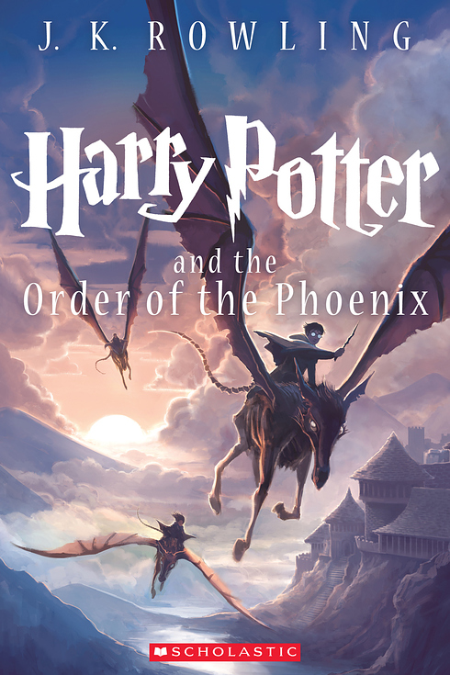
Figure 1.

Kazu Kibuishi, illust., Harry Potter and the Order of the Phoenix, J.K. Rowling.
Figure 2.

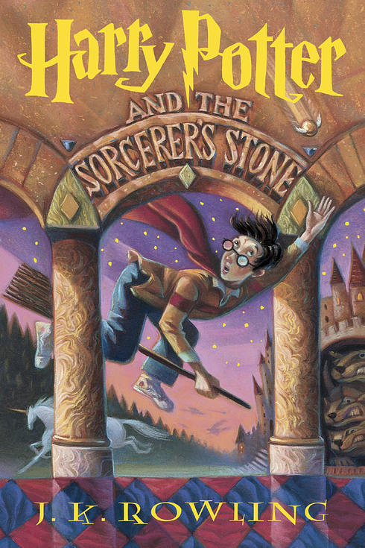
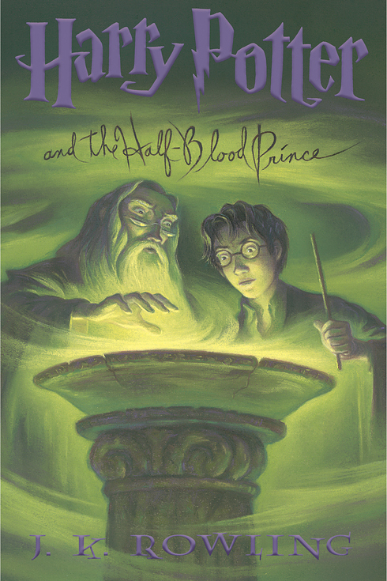
Figure 3. Figure 4.

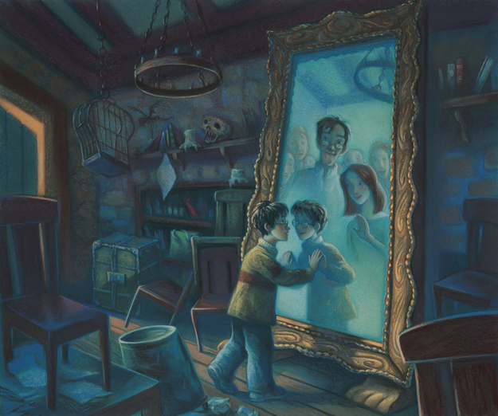
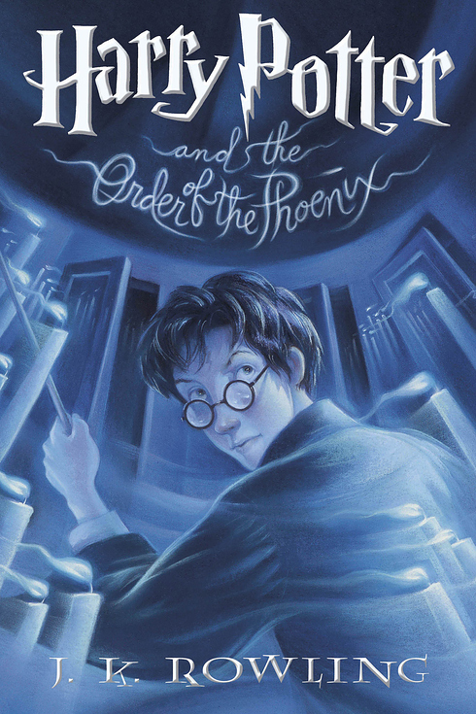
Figure 5. Figure 6.
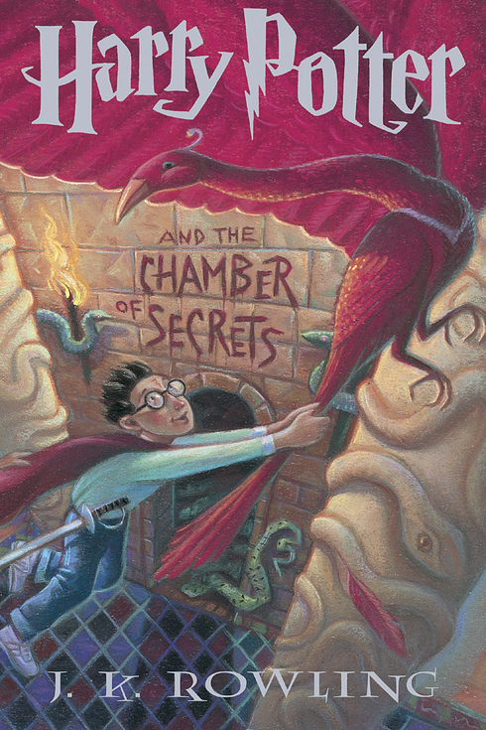
Figure 7. Figure 8.
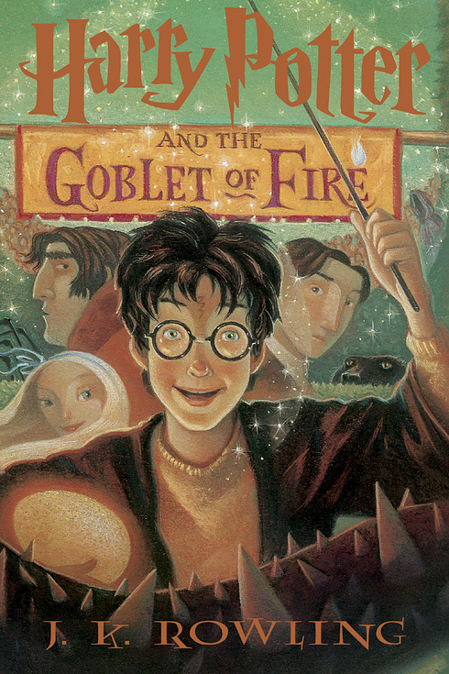

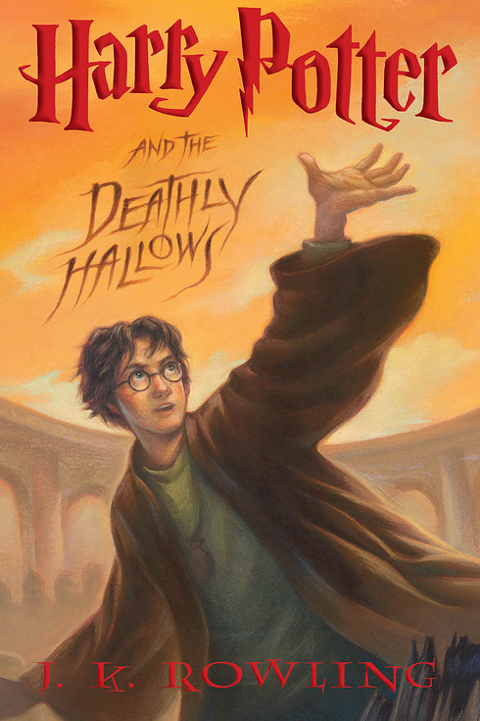
Figure 9.

Works Cited

“Read the FULL JK Rowling Interview.” BBC 18 July 2005. Web. 20 Feb. 2014.

Green, John. The Fault in Our Stars. New York: Dutton, 2012. Print.

Riordan, Rick. Percy Jackson. Hamburg: Carlsen, 2004. Print.

Zimmerman, Virginia. "Harry Potter and the Gift of Time." Children's Literature. 37. (2009): 194-215. Web. 12 Mar. 2014. <http://www.facstaff.bucknell.edu/vlzimmer/vz.harrypotter.pdf>.

Zimmerman, Virginia. "The Gift of Time." Children's Literature. 37. (2009): 194-215. Print. <http://www.facstaff.bucknell.edu/vlzimmer/vz.harrypotter.pdf>.

