How A Comma Gave Americans The Right To Own Guns
- By Christina Sterbenz, www.businessinsider.com
- August 12th, 2013
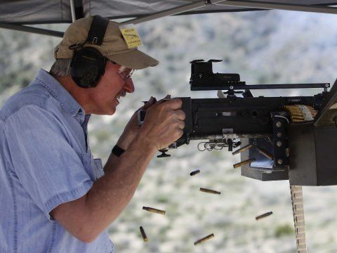
A recent poll suggests Americans will consider the gun debate a pivotal point in the 2014 elections. So we wanted to explore how Americans kept the right to bear arms in the first place. As it turns out, grammar is the culprit.
Take a look at the Second Amendment:
"A well regulated Militia, being necessary to the security of a free State,the right of the people to keep and bear Arms, shall not be infringed."
That little, red comma caused the Supreme Court to strike down D.C.'s ban on handguns, the country's strictest gun control law to date.
Before the Supreme Court heard the case, the D.C. circuit court of appeals nixed the ban, too. "According to the court, the second comma divides the amendment into two clauses: one 'prefatory' and the other 'operative.' On this reading, the bit about a well-regulated militia is just preliminary throat clearing; the framers don’t really get down to business until they start talking about 'the right of the people ... shall not be infringed,'" The New York Times reported.
Gun control proponents argue the founders used commas more frequently than common English today, Ross Guberman wrote in his legal writing blog. Some historians even claim that many states ratified a version of the Second Amendment with only two commas, not three. The extra commas don't mean much in that context, the argument goes.
Anti-gun academics have also argued the framers really meant "A well regulated militia ... shall not be infringed," the Times said. Phrases surrounded by commas can often be left out of a sentence without damaging the meaning.
Regardless of the grammatical volleying, the Supreme Court upheld the D.C. court's decision in 2008, invalidating the gun law. The high court invoked the same grammar logic as the appeals court.
"The Amendment's prefatory clause announced a purpose, but does not limit or expand the scope of the second part, the operative clause. The operative clause's text and history demonstrate that it connotes an individual right to keep and bear arms," Justice Antonin Scalia wrote in the majority.
The majority opinion said the court took the problem of handgun violence "seriously," but they couldn't "pronounce the Second Amendment extinct."
The Supreme Court has set the precedent on the grammar issues at the heart of the gun debate for now. However, the court may revisit gun control in an upcoming challenge to gun limits for people under 21.

