Lorde’s "Royals" Isn’t Anti-Rap, It’s Anti-Imperialism
The singer’s hit may be rough on hip-hop, but it’s really about growing up immersed in American culture in New Zealand.
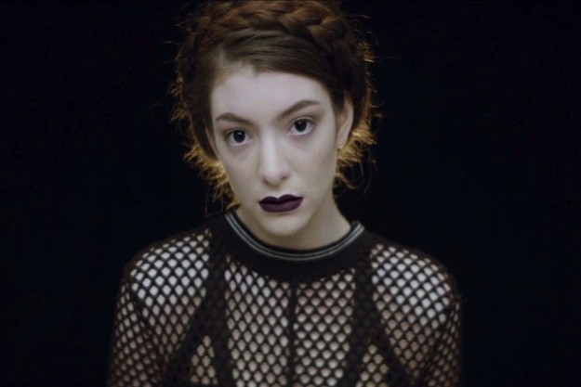
Matthew Perpetua posted on November 7, 2013 at 3:36pm EST

It was inevitable that Lorde’s out-of-nowhere smash hit “Royals” would inspire a backlash. It’s just what happens with anything that becomes suddenly popular, and difficult to avoid. But the negative reaction to Lorde and her signature hit goes beyond people just getting sick of hearing her voice. Lorde’s song is a critique of materialism in hip-hop, and she hasn’t been shy about criticizing other pop stars. Even if a huge number of people are on her side, she has still alienated a lot of people, and made some fans of rap particularly defensive.
The most extreme criticism of “Royals,” from both Spin’s Brandon Soderberg andFeministing’s Verónica Bayetti Flores, asserts that the song is inherently racist because most of the signifiers of ostentatious wealth listed in the chorus are tropes of mainstream rap. Soderberg, who dismisses the song’s lyrics as “crude and offensive stereotyping of hip-hop culture,” makes a good point in his piece about how bling-centric rap has been steadily fading from the mainstream over the past several years, though it was the center of pop a decade ago. From this perspective, it’s easy to get where Soderberg and Flores are coming from, and interpret the song as a “lecture” directed at black artists. But this read on the song only works if you completely disregard its actual context.
“Royals” is a song about growing up in New Zealand immersed in American cultural imperialism. The core of the song is alienation, sure, but the lyrics about pop culture are far more ambivalent than they are angry and strident. This is part of why it has resonated with so many people — Lorde isn’t saying that she doesn’t like this music, only that she sees a disconnect between the hyper-consumerist fantasy at the core of contemporary pop and the actual lives of anyone she knows. “I’ve always listened to a lot of rap,” she recently told New York Magazine. “It’s all, look at this car that cost me so much money, look at this Champagne. It’s super fun. It’s also some bullshit. When I was going out with my friends, we would raid someone’s freezer at her parents’ house because we didn’t have enough money to get dinner. So it seems really strange that we’re playing A$AP Rocky.”
If you grow up in the United States, it can be very easy to have no perspective on living in a culture dominated by art and media from another country. Some music from around the world seeps into mainstream American culture, but it’s never dominant, and music from abroad is made with the understanding that you have to cater to the American market to be a big star. Americans are used to the rest of the world bending over backwards to blend in with their culture, and think nothing of foreign stars from ABBA and Björk to Shakira and Phoenix singing in their second language to appeal to the English-speaking world. Americans are almost never asked to adapt, and very rarely have to feel as though their culture is being infiltrated by the value systems of foreign nations.
This context may get lost a bit when “Royals” is played in the United States, but it clicks with American listeners because this sort of cultural imperialism happens within the U.S. too. The “culture wars” that have informed the past few decades of American politics are rooted in a belief that the values of media produced and promoted almost exclusively by companies based in New York and California are disconnected from the majority of the country. On a more personal level, it’s just easy to look at mainstream culture and feel disenfranchised, that no one is speaking for you.
“Royals” may be ambivalent about music, but it’s openly defiant when it comes to class and this sort of imperialism. It may well be the most leftist song to become a major hit in years, at least in that it’s focused on rejecting wealth and privilege, and questioning capitalist ideas that encourage people from lower classes to buy into a system that is mostly rigged against them. Lorde’s song takes pride in not coming from money, and asks the listener to give some thought to why they want to buy into a glamorous fantasy. If it seems like Lorde is being especially rough on rap, but it’s mainly just because she’s a fan, and it’s the genre that is most invested in this fantasy. There are a lot of valid reasons why African-American culture in particular is invested in these material fantasies, but that’s not really what Lorde is talking about here. She’s mainly interested in the unintended cultural consequences of those values on the other side of the globe, and perhaps pushing Americans to consider for a moment that their pop culture is not happening in a vacuum.

