The Science of Mental Time Travel: Memory and How Our Ability to Imagine the Future Made Us Human
By Maria Popova
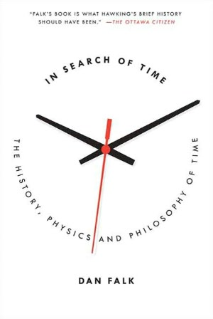
Shedding light on “the cognitive rudder that allows our brains to navigate the river of time.”
Lewis Carroll’s Alice in Wonderland remains one of my all-time favorite books, largely because Carroll taps his training as a logician to imbue the whimsical story with an allegorical dimension that blends the poetic with the philosophical. To wit: The Red Queen remembers the future instead of the past — an absurd proposition so long as we linear and memory as beholden to the past, and yet a prescient one given how quantum physics (coincidentally, a perfect allegorical exploration of Wonderland) conceives of time and what modern cognitive science tells us about how elastic our experience of time is. As it turns out, the Red Queen is far more representative of how human memory actually works than we dare believe.
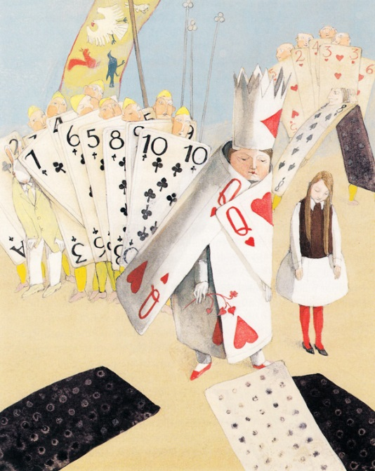
“To be human,” writes Dan Falk in In Search of Time: The History, Physics, and Philosophy of Time (public library), “is to be aware of the passage of time; no concept lies closer to the core of our consciousness” — something evidenced by our millennia-old quest to map this invisible dimension. One of the most remarkable and evolutionarily essential elements of experiencing time through human consciousness is something psychologists and cognitive scientists call mental time travel — a potent bi-directional projection that combines episodic memory, which allows us to draw on our autobiographical experience and call up events, experiences, and emotions that occurred in the past, with the ability to imagine and anticipate future events. Falk puts it unambiguously:
Without it, there would be no planning, no building, no culture; without an imagined picture of the future, our civilization would not exist.
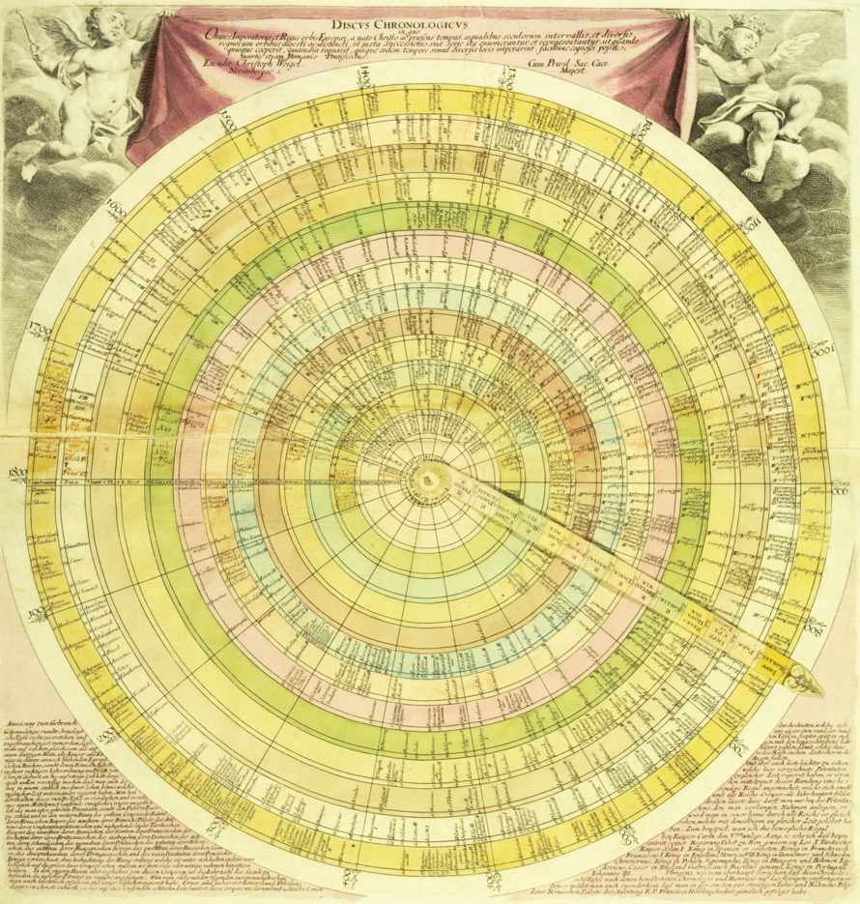
As it turns out, episodic memory — a term coined in the early 1970s by Canadian neuroscientist Endel Tulving, author of the seminal book Elements of Episodic Memory — is central to our capacity for mental time travel and, according to many scientists, fairly unique to humans. Unlike other facets of memory, such as the acquisition of new skills, which are rooted in the here-and-now, Falk points out that episodic memory allows us “to peer back across time, using our imagination to revisit just about any event that we choose.” This mental reliving of the past may be the root of some distinct human maladies — take the wistful reminiscence over a lost love, for instance — but it is also central to our evolutionary survival, allowing us to anticipate future outcomes based on past ones and thus to plan better and be more prepared for what tomorrow may bring. (The dark side of this evolutionarily beneficial faculty is that our over-planning often ends up shortchanging our happiness.)
And yet the benefits outweigh the costs, in evolutionary terms. Falk explains:
The capacity for mental time travel gave our ancestors an invaluable edge in the struggle for survival. They believe there is a profound link between remembering the past and imagining the future. The very act of remembering, they argue, gives one the “raw material” needed to construct plausible scenarios of future events and act accordingly. Mental time travel “provides increased behavioral flexibility to act in the present to increase future survival chances.” If this argument is correct, then mental time travel into the past — remembering — “is subsidiary to our ability to imagine future scenarios.” Tulving agrees: “What is the benefit of knowing what has happened in the past? Why do you care? The importance is that you’ve learned a lesson,” he says. “Perhaps the evolutionary advantage has to do with the future rather than the past.”
Discus chronologicus, a depiction of time by German engraver Christophe Weigel, published in the early 1720s; from Cartographies of Time.
Modern neuroscience appears to confirm that line of reasoning: as far as your brain is concerned, the act of remembering is indeed very similar to the act of imagining the future.
Though we might not be able to “remember” the future, as the Red Queen does, we do envision it in ways strikingly similar to how we picture events from the past — Falk notes that fMRI studies indicate we use similar regions in the brain’s frontal and temporal lobes when thinking about events in either direction of time. What’s more, psychologists have found that much like it’s harder for us to remember an event in the distant past than a recent one, it’s harder for us to imagine an event in the distant future than one expected to take place soon. This hints at the massively misguided way in which we think of and evaluate memory, which we falsely depict as a recording device, versus foresight. Falk writes:
When we imagine the future, we know what we picture is really just an educated guess; we may be right in the broad brushstrokes, but we are almost certainly wrong in the details. We hold memory to a higher standard. We feel — most of the time — that our memories are more than guesses, that they reflect what really happened. When confronted with a conflicting account of how last week’s party unfolded, we cling to our beliefs: He must be mistaken; I know what I saw.
Falk cites the Harvard psychologist Daniel Schacter:
[The brain is] a fundamentally prospective organ that is designed to use information from the past and the present to generate predictions about the future. Memory can be thought of as a tool used by the prospective brain to generate simulations of possible future events… We tend to think of memory as having primarily to do with the past… And maybe one reason we have it is so that we can have a warm feeling when we reminisce, and so on. But I think the thing that has been neglected is its role in allowing us to predict and simulate the future.
In order to mentally time-travel into the future, the brain has to accomplish a couple of things at once — we activate our “semantic memory,” which encompasses our basic knowledge of facts about the world and thus helps paint a backdrop for the imagined scene, and we call on our episodic memory, which pulls on our autobiographical library of remembered experiences to fill in specific details for this general scene. Curiously, episodic memory tends to be rather flawed but, according to two scientists Falk quotes, that’s okay since its core purpose is to provide “a more general toolbox that allowed us to escape from the present and develop foresight, and perhaps create a sense of personal identity.”
To be sure, just like elsewhere in cognitive science, human exceptionalism may be misplaced here — scientists have found that other species are also capable of varying degrees of mental time travel. Falk cites one of the most intriguing experiments, involving scrub jays. He writes:
Psychologist Nicola Clayton and her colleagues housed the birds on alternate days in two different compartments — one in which the jays always received “breakfast,” and one in which they did not. Then the birds were unexpectedly given extra food in the evening, at a location where they could access either compartment. The jays promptly cached their surplus — and they preferentially cached it in the “no breakfast” compartment. Because the birds were not hungry at the time of the caching, the researchers claim that the birds truly anticipated the hunger they would experience the next morning.
Still, the fact that humans are capable of remarkably elaborate and detailed mental time travel reveals something unique about our evolution and the development of such hallmarks of humanity as language and theory of mind. Falk writes:
In all likelihood, the capacity for mental time travel did not develop in isolation but rather alongside other crucial cognitive abilities. “To entertain a future event one needs some kind of imagination,” [the prominent psychologists Thomas] Suddendorf and [Michael] Corballis write, “some kind of representational space in our mind for the imaginary performance.” Language could also play an important role. Our language skills embrace mental time travel by the use of tenses and recursive thinking; when we say “A year from now, he will have retired,” we’re imagining a future time in which some event — which has not yet happened — will lie in the past… Mental time travel may have been “a pre-requisite to the evolution of language itself.” If mental time travel is indeed unique to humans, it may help us understand why complex language is also, apparently, unique.
In fact, the development of mental time travel may even be how the concept of time itself came into existence — according to Suddendorf and Corballis, our species emerged victorious in “an extraordinary evolutionary arms race” largely due to our growing capacity for foresight and sophisticated language, which not only gave us culture and “coordinated aggression” but also, for the first time in evolutionary history, enabled us to understand the concepts of “past” and “future.” The mental reconstruction of what has been and the imagining of what could be, they argue, created the concept of time and enabled us to understand the continuity between the past and the future. Falk, once again, puts it succinctly:
Mental time travel may indeed be the cognitive rudder that allows our brains to navigate the river of time.
In Search of Time is a fantastic read in its entirety, covering such facets of life’s most intricate dimension as how the calendar was born, why illusion and reality aren’t always so discernible from one another, and what the ultimate fate of the universe might be. Complement it with these seven excellent books on time and a fascinating read on how our memory works.

