Who Runs the World
Man versus nature has been an ever-present conflict since Adam’s expulsion from Eden. For much of human history, man believed he had won as colonization spread across the globe. Throughout all this time, Homer’s Odyssey, the original explorer’s tale, whose hero Odysseus travels to exotic and uncharted lands on his 10 year journey home, has not lost its appeal, but by the time Rome-based artist Nicholas Poussin became consumed with Classical characters and landscapes in the mid-1600s, perspective on this supposedly-universal theme had changed. While Homer’s Odyssey uses Polyphemus’ cave to reveal the conscious choice in his status between monster and man, Nicolas Poussin’s 1649 painting “Landscape with Polyphemus” shows the foolhardiness in believing nature can be entirely domesticated, as the world is too large to be explored, seen, understood, and therefore controlled, by man.
Upon arriving on the island of the Cyclopes, Odysseus surveys the fertile land and notes that “[men] could have made this island a strong settlement” (9.130)—a not-so-subtle dig at the immortal Cyclopes failure to cultivate the abundant resources around them, implicitly making them inferior. This androcentric (man’s p.o.v.) attitude extends to Odysseus’ view of Polyphemus’ dwelling. Polyphemus lives “at the edge of the land” (9.182), placing him on the outskirts of civilization. His “cave,” a barbaric hole more than a home, is “high, and overgrown with laurels,” introducing the Cyclopes potential for civility, as they are literally above all others, and even the wild overgrowth is composed of “laurels,” the sacred leaves of Apollo signifying the highest human achievements (9.183).
Polyphemus’ possessions similarly suggest personhood; like all men, he uses constructed walls and barriers to lay claim to what’s his. His sheep and goats are kept “stabled” in his cave, surrounded by a “fenced yard” with “high wall” (9.183-85). The domestication of animals and declaration of ownership over property shows a structured society that has progressed beyond hunter-gathers and nomads, though only barely, as the wall is made of “grubbed-out boulders” (9.185)—a raw, unrefined material barely separated from nature. These traditional markers of a stratified society actually point to the segmented nature of the Cyclopes’ community. Polyphemus provides for himself, and only himself, and ever structure separates him from, rather than connects him to, others.
Odysseus explicates this isolation: Polyphemus herds “alone, for he did not range with others, but stayed by himself; his mind was lawless,” syntactically linking this isolation to “lawless[ness]” through semi-colon (9.188-89). This is ironic on two counts: Odysseus’ repeated description of the “high” and “tall” setting suggests this intentional isolation is due to Polyphemus’ assumed superiority over others (9.183-86), while Odysseus himself assumes an attitude of superiority over the Cyclopes, and of course, the only thing that made Odysseus superior, his companions, are now all dead.
Odysseus seems oblivious of his bias, prefacing his partial statements with “in truth” (9.190), referring to Polyphemus as a “monster of a man” (9.187) in one breath, and saying he is “not like a man” in the next (9.191). The difference between monster and man seems to come down to each’s relationship with nature: men are “eaters of bread” (9.191), while monsters are “like a wooded peak of the high mountains seen standing away from others” (9.191-92). One harnesses nature, creating something new through combination; the other becomes one with the setting, remaining in isolation.
Polyphemus can certainly barely be “seen standing away from others” (9.192) in Poussin’s “Landscape with Polyphemus,” as he almost looks too “like a wooded peak of the high mountains” (9.191). The painting depicts nymphs lounging in foreground, only vaguely aware of lecherous satyrs in the bushes, while men toil away, attempting to cultivate the land before them; Polyphemus appears alone, above, barely distinguishable from the mountain he occupies, back turned to the viewer (see fig. 1). The painting’s title is appropriate, as the “Landscape” is assuredly the focus, and Polyphemus appears like an afterthought. The sky and mountains literally pale in comparison to the land, which is thick with foliage and rich in color (see fig 1).
The figures at the foreground seem as oblivious to the fertile soil before them, though they are presumably overseeing the plowing, as they are to Polyphemus above. Instead they gaze wistfully off into the distance at the island beneath the largest tree in the painting—ignoring the power and potential of nature entirely for the glory of manmade structures, though they are miniscule in comparison. Humans find superiority in self at eye-level, rather than on high, ignoring the actual task at hand to idealize the potential of human construction. Never mind that it will always be overshadowed by the products of nature and the gods.
Anyone viewing the painting, however, is outside all of this, and more far-sighted than any of the figures in the scene. Poussin’s perspective reveals humans’ faulty focus on farming. The highly civilized characters in front wear laurels, but are still vulnerable to the baser creatures driven by bodily desires in the far right. The only woman who appears to notice their approach is already half-exposed and defenseless—the vase next to her has fallen over, heralding disorder’s entrance into the otherwise idyllic scene (see fig. 1).
While Polyphemus’ apparent superiority and accompanying isolation is no less objectionable than his choice to live in a cave, the true fools in Poussin’s painting are the people. The servants farming the land, mindlessly caring out orders to control and harness the power of the earth, are without clear direction or faces, no more human than the tools they use to plow. Their masters ignore both the toil before them and the danger to their right, their sight firmly fixed on their dream of civilization—directly above the danger. They display the same steadfast and limited view as Odysseus while surveying Polyphemus’ cave. The only difference is the storyteller is now one more step removed.
Odysseus pushed the boundaries of the earth, travelling the known world and to the Underworld beyond. And while the seas proved turbulent and unreliable, land always offered the potential for new life. Land was a blank canvas on which man could create civilization. And so man did. The rise of the Ancient Greeks and Romans expanded human’s ability to create cities in the form of physical structures and government. Neither Alexander the Great nor Caesar managed to maintain control of his empire, however, creating a certain element of skepticism by the time Europeans turned their dreams of conquest to colonizing North and South America in the mid-1600s. Nicholas Poussin’s view from the ruins of conquerors while living in Rome, and his resulting painting, “Landscape with Polyphemus,” shows this shift in perspective. The world is still man’s oyster, but only if he limits his sight, and therefore knowledge, to utterly ignore his surroundings.

Citation Information
Songs: Mention the “title of the song” and the lyricist when you first introduce the song, afterwards: (Author of the lyrics’ last name) e.g., (Swift)

Art: Mention the title of the painting and the artist’s name when you first introduce the piece, afterwards: (Artist’s last name) e.g., (Monet)
N.B. I highly recommend you include a copy of your art in an appendix, meaning you have a page after your essay labelled “Appendix” and says “figure 1” directly above the art. In text citation would read (see fig. 1). A sample appendix is on the next page.

The Odyssey: Introduce Homer’s Odyssey and give context for any specific scenes to introduce quotes. In-text citations for the Odyssey are strange because it’s a poem. They’re divided by book and line number with period (but no space) separating the numbers. For example, if you’re referring to Book 9 line 235, your in text citation would be (9.235).

Appendix
Figure 1.
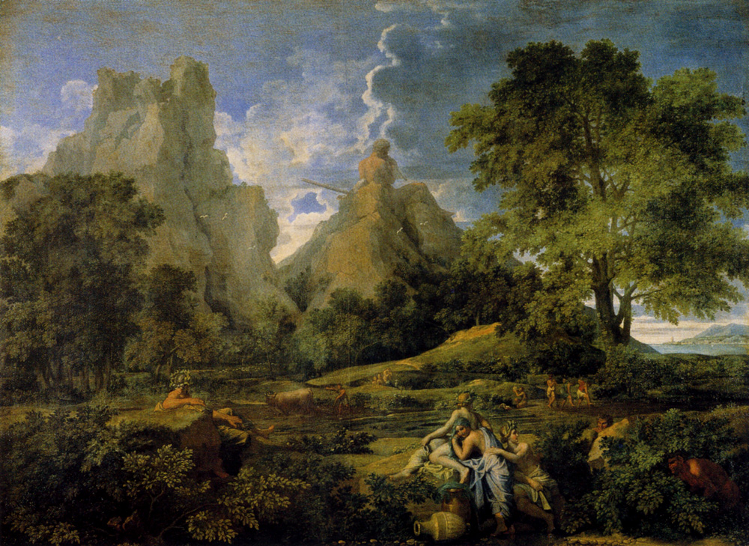
Outline/Thoughts:
Poussin seems to ask what humans “see[]” at all
-Perspective from behind humans
Painting after the fall of Roman and Greek civilization
-Humans with laurels gaze off to far right corner civilization/ideal
-Underlings work to cultivate nature in front of them
Polyphemus above (playing pan flute)
-Satyrs in bushes
- heroic landscapes and idealized or poetic ones was adopted by the exhibition here ; it should probably be modified; from around 1650 of three different categories : moralizing landscapes, landscapes with horror and death, mythological landscapes.
-Different themes, solitude and retreat, the order of the universe, the power of nature, run through, at times together, all of these magnificent compositions.

